Azure Databricks Lessons 1 and 2 Lab Guide
From Azure workspace creation to a governed Delta table
Audience Trainer, Azure administrator and 14 beginner learners
Scope From first workspace navigation to a governed Delta table
Environment One Premium Azure Databricks workspace • 14 learners • one learner schema each

Lab result
The trainer prepares one Premium Azure Databricks workspace and one isolated schema for each learner. Every learner creates a notebook, runs Python and SQL, builds a Spark DataFrame, and saves the final result as a governed Delta table.
FINAL TABLE FOR LEARNER 01
training_lab.student_01.orders
Part | Owner | Estimated time | Evidence
0 Preflight | Trainer or admin | 30 minutes before class | Sign-in, compute and schema test pass
1 Azure workspace setup | Azure admin | 30 to 45 minutes | Workspace launches
2 Classroom access | Databricks admin | 20 to 30 minutes | Group, schemas and grants exist
3 First notebook | Learner | 45 minutes | Python, SQL and Markdown run
4 Orders and Delta | Learner | 55 minutes | Governed table and history
5 Challenge and cleanup | Learner and trainer | 20 minutes | Assessment evidence collected

SAFETY: Never place credentials in a notebook. Never grant administrator access simply to bypass a lab error.

Part 0 Trainer preflight

Run these checks before learners arrive
Check | Pass condition | If it fails
Workspace | Trainer and test learner can launch it | Check tenant, entitlement and account mapping
Compute | spark.range(5).count() returns 5 | Use serverless or the approved classic fallback
Catalog | training_lab appears in Catalog | Check metastore and USE CATALOG
Schemas | student_01 through student_14 exist | Run the reviewed setup SQL
Permissions | Test learner creates only in the assigned schema | Correct the narrow schema grant
Cost control | Serverless policy or auto termination is active | Apply the approved compute policy

PYTHON
print(spark.range(5).count())
# Expected: 5

Learner mapping
Learner number | Assigned schema | Verified
01 | training_lab.student_01 | ☐
02 | training_lab.student_02 | ☐
03 | training_lab.student_03 | ☐
04 | training_lab.student_04 | ☐
05 | training_lab.student_05 | ☐
06 | training_lab.student_06 | ☐
07 | training_lab.student_07 | ☐
08 | training_lab.student_08 | ☐
09 | training_lab.student_09 | ☐
10 | training_lab.student_10 | ☐
11 | training_lab.student_11 | ☐
12 | training_lab.student_12 | ☐
13 | training_lab.student_13 | ☐
14 | training_lab.student_14 | ☐

Part 1 Create the Azure Databricks workspace

1.1 Prerequisites
- An Azure subscription and permission to create the approved resources.
- A dedicated training resource group or an approved shared resource group.
- A supported Azure region that meets organizational data-residency rules.
- A workspace naming convention and cost owner.
- A Microsoft Entra group containing the 14 learner identities.

1.2 Create the resource in the Azure portal
1. Sign in to the Azure portal with the approved administrator account.
2. Select Create a resource.
3. Search for Azure Databricks and select Create.
4. Choose the subscription and resource group.
5. Enter a unique workspace name and approved region.
6. Select the Premium pricing tier because this course uses Unity Catalog governance.
7. Choose the workspace and networking model approved by the organization.
8. Review the settings, select Review + create, and wait for validation.
9. Select Create. After deployment finishes, open the resource and select Launch Workspace.
CURRENT UI NOTE: Azure portal field labels can change. Keep the subscription, resource group, region, pricing tier, networking choice and identity model consistent with your approved design.

Verification
- The Azure deployment shows Succeeded.
- Launch Workspace opens Azure Databricks.
- The trainer can see Workspace, Catalog and Compute navigation.

Part 2 Configure classroom access

2.1 Add the learner group
1. Open workspace administration settings.
2. Add or sync the approved Microsoft Entra learner group.
3. Grant the minimum workspace entitlement required for the class.
4. Verify one test learner can sign in.

2.2 Create the catalog and schemas
SQL
-- Run as a metastore or catalog administrator
CREATE CATALOG IF NOT EXISTS training_lab;
CREATE SCHEMA IF NOT EXISTS training_lab.student_01;
CREATE SCHEMA IF NOT EXISTS training_lab.student_02;
-- Continue through student_14

2.3 Grant only the required privileges
SQL
GRANT USE CATALOG
ON CATALOG training_lab
TO `databricks-learners`;
GRANT USE SCHEMA, CREATE TABLE
ON SCHEMA training_lab.student_01
TO `learner01@example.com`;
-- Repeat for each mapped learner
LEAST PRIVILEGE: A learner should create tables only in the assigned schema. The trainer or administrator owns catalog-level setup.

2.4 Configure compute
Use serverless notebook compute when the workspace has Unity Catalog enabled, the region supports serverless and organizational policy permits it. Otherwise, create one governed classic all-purpose configuration for the class.
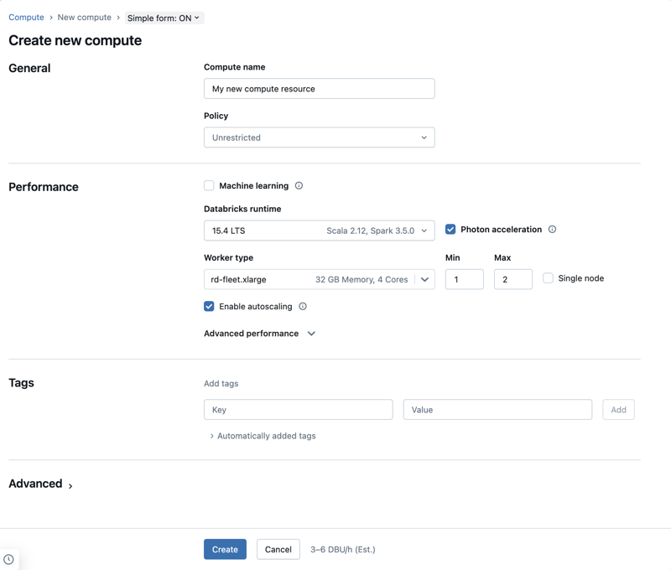
Recent simple compute form. Available policies and fields depend on the workspace configuration.

Classic fallback settings
- Use the trainer-approved compute policy.
- Use a current supported runtime or approved long-term-support runtime.
- Select small worker limits for the classroom workload.
- Enable autoscaling only if policy allows it.
- Enable auto termination.
- Use a Unity Catalog compatible access mode, normally Standard for this class.
- Grant the learner group permission to use the compute, not to create unrestricted compute.

Verification
PYTHON
print('Spark version:', spark.version)
print('Row count:', spark.range(5).count())

Part 3 Learner lab Create the first notebook

Step 1 Open the workspace
1. Sign in to the Azure portal with your learner account.
2. Open the training resource group.
3. Select the Azure Databricks workspace.
4. Select Launch Workspace.
5. Confirm your own account and the correct organization or tenant appear.
STOP IF: Another learner or administrator identity appears. Sign out and correct the account before continuing.

Step 2 Create a notebook
1. In the left sidebar, select + New.
2. Select Notebook.
3. Name the notebook 01_foundations_student_01.
4. Choose Python as the default language if prompted.
5. Select Serverless or the trainer-approved compute from the compute selector.
6. Wait until the notebook shows a ready or connected state.
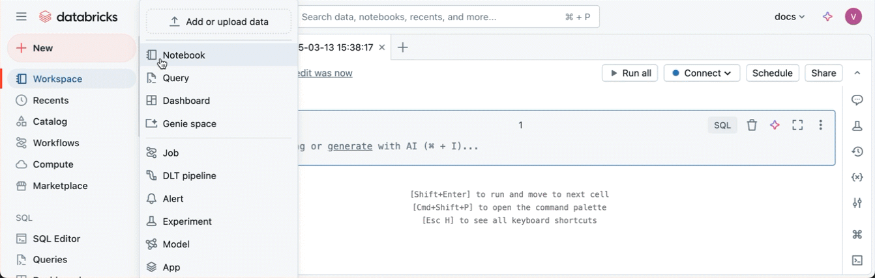
Recent New menu with Notebook selected.

Step 3 Understand the notebook toolbar
Recent notebook toolbar. The compute selector appears near the top of the notebook.
- The notebook name identifies the workspace object.
- The compute selector identifies what will execute the code.
- Run cell executes the selected cell.
- Run all executes cells in notebook order; use it only after checking destructive cells.
- Cell controls add Python, SQL or Markdown content.

Step 4 Run basic Python
PYTHON
print('Hello Azure Databricks!')
EXPECTED OUTPUT: Hello Azure Databricks!
The notebook contained the instruction. Connected compute executed it.
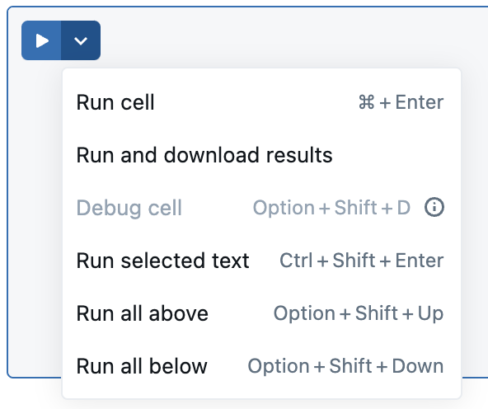
Recent cell run controls. Use the run icon beside the cell.

Step 5 Check the Spark session
PYTHON
print('Spark version:', spark.version)
spark.range(5).show()
spark is the automatically available Spark session. The second line creates a tiny distributed range and show requests the result.

Step 6 Create a student DataFrame
PYTHON
students = [
(1, 'Asha', 85),
(2, 'Ravi', 72),
(3, 'Meena', 91),
(4, 'Imran', 68)
]
columns = ['student_id', 'student_name', 'marks']
students_df = spark.createDataFrame(students, columns)
students_df.printSchema()
display(students_df)
student_id | student_name | marks
1 | Asha | 85
2 | Ravi | 72
3 | Meena | 91
4 | Imran | 68

CHECKPOINT: The schema contains three columns and display shows four rows.

Step 7 Filter the DataFrame
PYTHON
passed_df = students_df.filter(students_df.marks >= 75)
display(passed_df)
student_id | student_name | marks
1 | Asha | 85
3 | Meena | 91

filter is a transformation. display is the action that requests the result.

Step 8 Create a temporary SQL view
PYTHON
students_df.createOrReplaceTempView('students')
The view name exists only in the current Spark session. It lets SQL refer to the DataFrame.

Step 9 Query the view with SQL
SQL
%sql
SELECT student_name, marks
FROM students
WHERE marks >= 75
ORDER BY marks DESC;
student_name | marks
Meena | 91
Asha | 85

LEARNING POINT: Python created the DataFrame and SQL queried the same Spark data.

Step 10 Check identity and namespace
SQL
%sql
SELECT
current_user() AS logged_in_user,
current_catalog() AS current_catalog,
current_schema() AS current_schema;
- Verify logged_in_user is your identity.
- Record the catalog and schema values.
- If the current schema is not your assigned schema, use the full three-level name in all table commands.

Step 11 Add Markdown documentation
MARKDOWN
%md
# Student Marks Analysis
This notebook demonstrates:
1. Python execution
2. Spark DataFrame creation
3. DataFrame filtering
4. SQL querying
5. Identity and namespace verification
A good notebook explains its purpose, assumptions, input, transformations and validation. Do not keep only unexplained code.

Checkpoint
- Python cell ran.
- Spark version displayed.
- Four-row DataFrame displayed.
- Two students passed the filter.
- SQL returned Meena and Asha.
- Markdown title appears.

Part 4 Learner lab Orders and Delta

Step 12 Create order data
PYTHON
from pyspark.sql import functions as F
orders = [
('O101', 'Laptop', 1, 60000.0),
('O102', 'Mouse', 2, 800.0),
('O103', 'Keyboard', 3, 1500.0)
]
columns = ['order_id', 'product', 'quantity', 'unit_price']
orders_df = spark.createDataFrame(orders, columns)
orders_df.printSchema()
display(orders_df)

Step 13 Calculate total_amount
PYTHON
result_df = orders_df.withColumn(
'total_amount',
F.col('quantity') * F.col('unit_price')
)
display(result_df.orderBy(F.desc('total_amount')))
order_id | product | quantity | unit_price | total_amount
O101 | Laptop | 1 | 60000.0 | 60000.0
O103 | Keyboard | 3 | 1500.0 | 4500.0
O102 | Mouse | 2 | 800.0 | 1600.0

CHECKPOINT: Row count is 3 and the highest total_amount is 60000.0.

Step 14 Confirm your target schema
Replace student_01 with your assigned schema. Do not continue if the schema is missing or you are unsure of the assignment.
SQL
%sql
SHOW SCHEMAS IN training_lab LIKE 'student_01';
SHOW GRANTS ON SCHEMA training_lab.student_01;

Step 15 Save the result as a Delta table
PYTHON
result_df.write \
.format('delta') \
.mode('overwrite') \
.saveAsTable('training_lab.student_01.orders')
Read the code from top to bottom: result_df.write begins a DataFrame write; format selects Delta; overwrite makes this isolated lab rerunnable; saveAsTable writes the data and registers the three-level governed name.
Part | Value | Meaning
Catalog | training_lab | Training governance domain
Schema | student_01 | Learner-isolated area
Table | orders | Published order dataset

WARNING: Do not change the target to another schema. Do not use overwrite on an unverified production table.

Step 16 Validate the table data
SQL
%sql
SELECT *
FROM training_lab.student_01.orders
ORDER BY total_amount DESC;
- Confirm three rows.
- Confirm O101 has total_amount 60000.0.
- Confirm the five expected columns appear.

Step 17 Validate metadata and history
SQL
%sql
DESCRIBE DETAIL training_lab.student_01.orders;
DESCRIBE HISTORY training_lab.student_01.orders;
- Confirm format is delta.
- Confirm the table location is an approved managed or external location.
- Confirm a WRITE operation appears in history.
- Open Catalog and browse training_lab → student_01 → orders.

Step 18 Create a second table version
PYTHON
new_order_df = spark.createDataFrame(
[('O104', 'Dock', 1, 120.0, 120.0)],
['order_id', 'product', 'quantity', 'unit_price', 'total_amount']
)
new_order_df.write.format('delta').mode('append').saveAsTable(
'training_lab.student_01.orders'
)

Step 19 Inspect the new version
SQL
%sql
SELECT COUNT(*) AS row_count
FROM training_lab.student_01.orders;
DESCRIBE HISTORY training_lab.student_01.orders;
EXPECTED: The row count is 4. History contains another WRITE operation. Exact version numbers depend on prior reruns.

Step 20 Optional time travel
Read DESCRIBE HISTORY and select an existing earlier version. If the first write is version 0, this query returns the original three rows.
SQL
%sql
SELECT *
FROM training_lab.student_01.orders VERSION AS OF 0
ORDER BY total_amount DESC;
IMPORTANT: Do not assume version 0 is available in every reused environment. Select a version shown in history.

Independent challenge
Create training_lab.student_01.product_summary with product, units and revenue. Use the existing orders Delta table as the source.
PYTHON
summary_df = (spark.table('training_lab.student_01.orders')
.groupBy('product')
.agg(
F.sum('quantity').alias('units'),
F.round(F.sum('total_amount'), 2).alias('revenue')
))
summary_df.write.format('delta').mode('overwrite').saveAsTable(
'training_lab.student_01.product_summary'
)

Part 5 Troubleshooting
Symptom | Likely cause | Resolution
No compute attached | Notebook has no execution resource | Select approved compute and wait until ready
Cannot select compute | Missing permission, terminated compute or unavailable serverless | Check learner group, policy and workspace support
students view not found | Temp-view cell did not run in this session | Run cells in order
TABLE_OR_VIEW_NOT_FOUND | Wrong catalog, schema, object name or session | Copy the full name from Catalog and verify the namespace
PERMISSION_DENIED | Missing USE or CREATE privilege or wrong schema | Check current_user and SHOW GRANTS; fix the narrow grant
Column not found | Spelling or schema differs | Run printSchema and inspect the input
Unexpected duplicate rows | Append was rerun | Inspect history and validate business keys
Time travel version fails | The selected version does not exist | Read DESCRIBE HISTORY and choose an available version

Troubleshooting sequence
1. Read the full error and identify the first useful message.
2. Check notebook compute status.
3. Check current_user, catalog, schema and the exact three-level name.
4. Inspect the DataFrame schema and a small sample.
5. Check grants for permission errors.
6. Ask the trainer with the error text and failed object name.

Evidence and cleanup
Evidence | Pass condition | Complete
Notebook | Runs from top to bottom without changing code | ☐
Marks DataFrame | Four rows; filter returns Asha and Meena | ☐
Orders DataFrame | Three initial rows; O101 total is 60000.0 | ☐
Delta table | Assigned three-level table exists | ☐
History | At least two writes after append | ☐
Challenge | product_summary exists and is queryable | ☐
Explanation | Learner explains workspace, compute and catalog.schema.table | ☐

Cleanup responsibilities
- Learners stop after evidence collection and do not drop shared catalogs or schemas.
- The trainer terminates classic interactive compute or confirms auto termination.
- The trainer decides whether learner tables remain for assessment or are dropped after export.
- The Azure administrator deletes the dedicated training resource group only after the course and retention period are complete.
DESTRUCTIVE ACTION: Dropping training_lab would remove every learner object. Resolve the exact target, ownership and retention decision before running cleanup SQL.

Official references
Azure Databricks interfaces change frequently. The steps and screenshots in this package align with the current Microsoft Learn guidance available in September 2026. If a label moves, use the equivalent navigation item in your tenant.
- Create an Azure Databricks workspace — https://learn.microsoft.com/azure/databricks/admin/workspace/create-workspace
- Create and manage notebooks — https://learn.microsoft.com/azure/databricks/notebooks/notebooks-manage
- Configure classic compute — https://learn.microsoft.com/azure/databricks/compute/configure
- Delta Lake tutorial — https://learn.microsoft.com/azure/databricks/delta/tutorial
- Apache Spark documentation — https://spark.apache.org/docs/latest/

